Animesh Parab 88 T2-T21

**Assignment 1**

**Aim:-** Study and create an AWS EC2 instance.

**Lop mapped:-**

LO1- To understand the fundamentals of Cloud Computing to be fully proficient with Cloud-based DevOps solution deployment options to meet your business requirements.

**Theory:-**

Amazon Elastic Compute Cloud (Amazon EC2) is a web service that provides secure, resizable computing capacity in the cloud. It is designed to make web-scale cloud computing easier for developers.

Here's a detailed explanation of an AWS EC2 instance:

1. Virtual Server:

An EC2 instance is a virtualized computing environment that mimics a physical server. It runs an operating system of your choice and supports a wide range of applications, databases, and services.

2. Scalability:

One of the key benefits of EC2 is its scalability. You can easily scale your instances horizontally (adding more instances) or vertically (resizing an instance) to meet changing workloads. This elasticity helps you optimize performance while controlling costs.

3. Variety of Instance Types:

EC2 provides a variety of instance types optimized for different use cases. These instance types vary in terms of CPU, memory, storage, and network capabilities, allowing you to choose the best fit for your application's requirements.

4. Amazon Machine Image (AMI):

An AMI is a pre-configured template that contains the information required to launch an instance. It includes the operating system, application software, and any additional configuration you've applied. You can choose from a wide range of public AMIs or create your own custom AMIs.

5. Networking and Security:

Each EC2 instance is associated with a security group, which acts as a virtual firewall controlling inbound and outbound traffic. You can also assign Elastic IP addresses for consistent IP assignments, create Virtual Private Clouds (VPCs) for isolated networking, and configure network settings like subnets, routing tables, and network access control lists.

6. Cost Flexibility:

EC2 instances are available in different pricing models, including On-Demand (pay-as-you-go), Reserved Instances (upfront payment for long-term usage), and Spot Instances (bid-based pricing). This allows you to choose the most cost-effective option for your workload.

**Output:-**

LOGIN TO AWS ACCOUNT,

THEN SEARCH EC2.

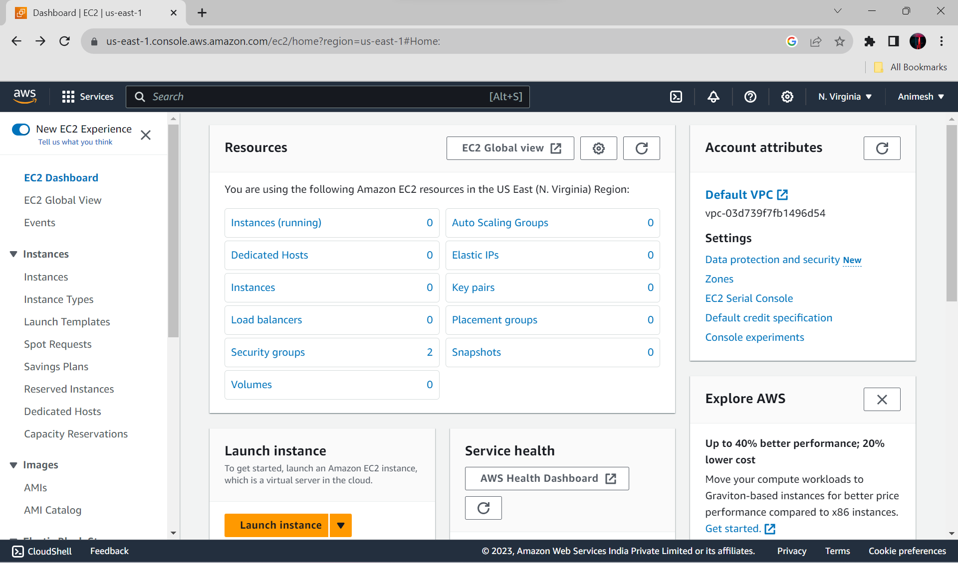

NOW CLICK ON LAUNCH / CREATE NEW INSTANCES.

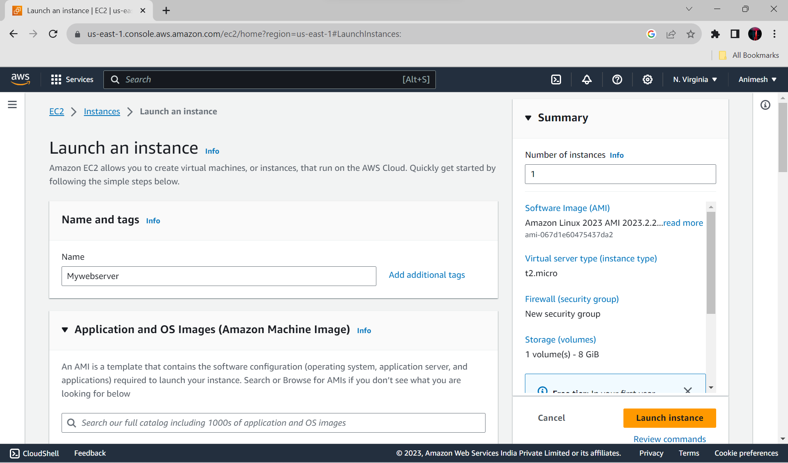

Choose any machine you want to create here I am creating UBUNTU(free tier).

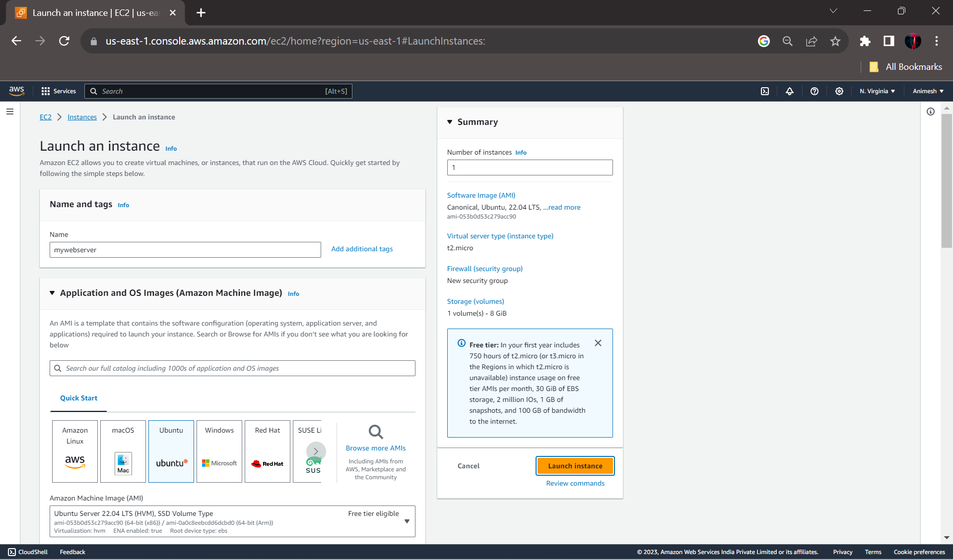

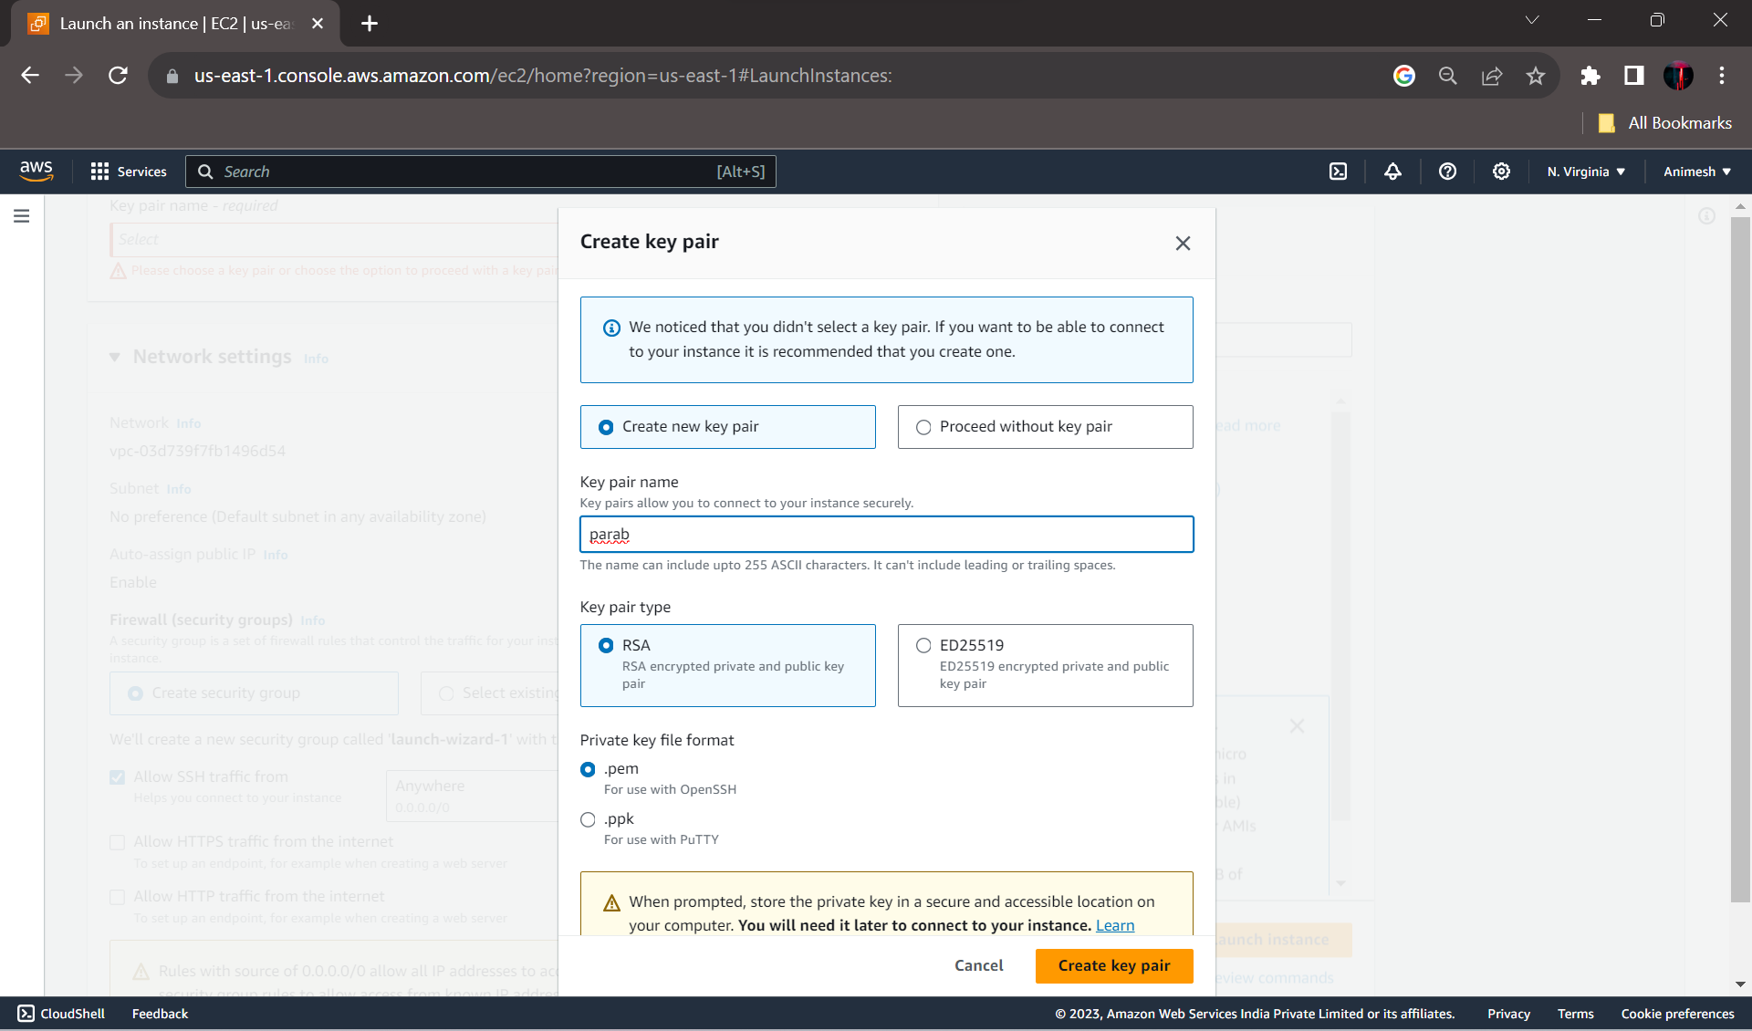

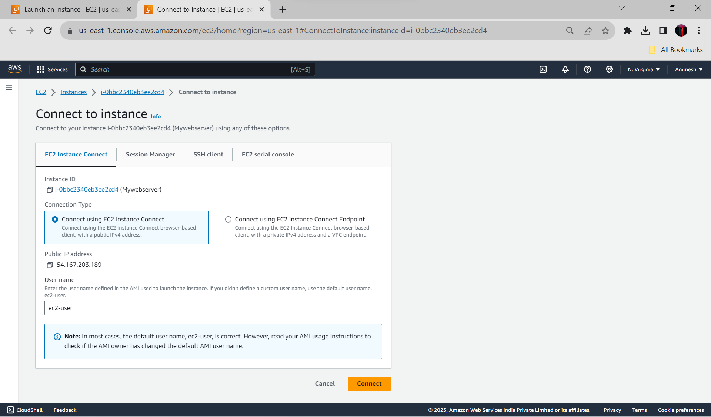

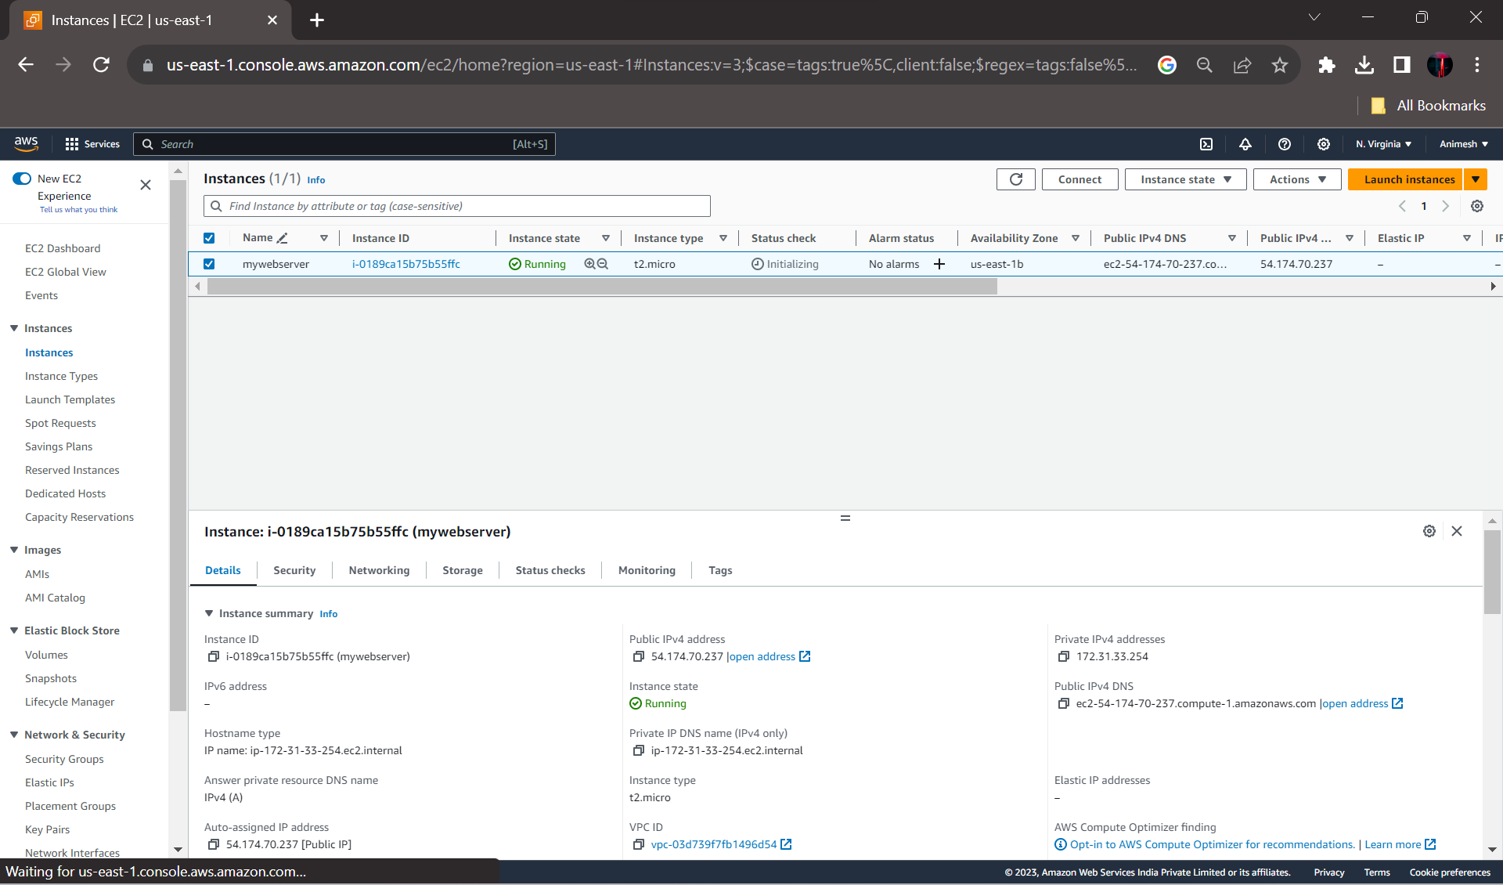

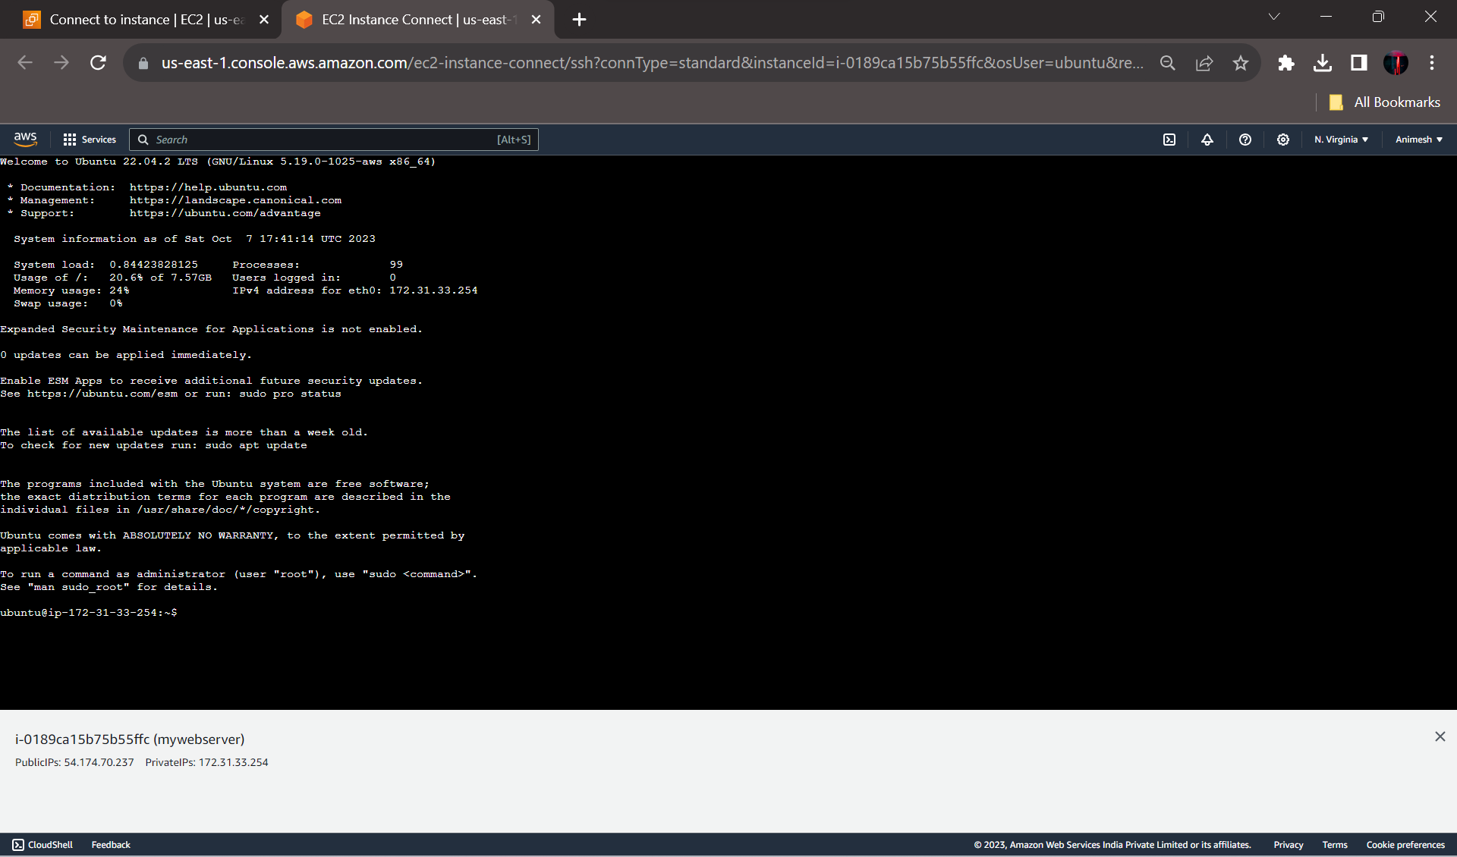

**Conclusion:-** In this, I have created an Amazon web services account and after creating the account I created instances successfully as shown above also I have run a virtual Unix environment on the created instance and lab outcome is also achieved.